|  |
| --- |
| **SIGN IN (to be read out loud)** |
| **Before induction of anaesthesia** |
| **Has the patient had their identity confirmed, procedure verified and consent checked?**  Yes |
| **Is the surgical site marked?**  Yes/not applicable |
| **Is the anaesthetic machine and medication check complete?**  Yes |
| **Does the patient have a:**  **Known allergy?**  Yes No  **Difficult airway/aspiration risk?**  Yes No  **Risk of >15% blood loss?**  No  Yes and adequate IV access/fluids planned  Patient position in theatre known?  Antibiotics at induction? Yes/NA  Estimated surgery time is……….  Team discusses perioperative plan & designates roles  Any concerns? |

**Surgical Safety Checklist**

|  |
| --- |
| **TIME OUT (To be read out loud)** |
| **Before start of surgical intervention (e.g. skin incision)** |
| **Surgeon, Anaesthetist and theatre nurse/assistant verbally confirm:**  What is the patient’s name? ___________  Procedure, site and position are confirmed? _____________________________________ |
| **Anticipated critical events**  **Surgeon:**  Anticipated blood loss?  Are there any specific equipment requirements or special investigations?  Are there any critical or unexpected steps you want the team to know about?  **Anaesthetist:**  Are there any patient specific concerns?  What is the patient’s ASA grade?  What monitoring equipment and other specific levels of support are required e.g. blood?  **Nurse/Assistant:**  Has the sterility of the instrumentation been confirmed?  Are there any equipment issues or concerns? |
| **Has the surgical site infection (SSI) bundle been undertaken?**  Antibiotic prophylaxis within the last 60 minutes  Patient warming. State temperature________  Hair removal  Antisepsis |

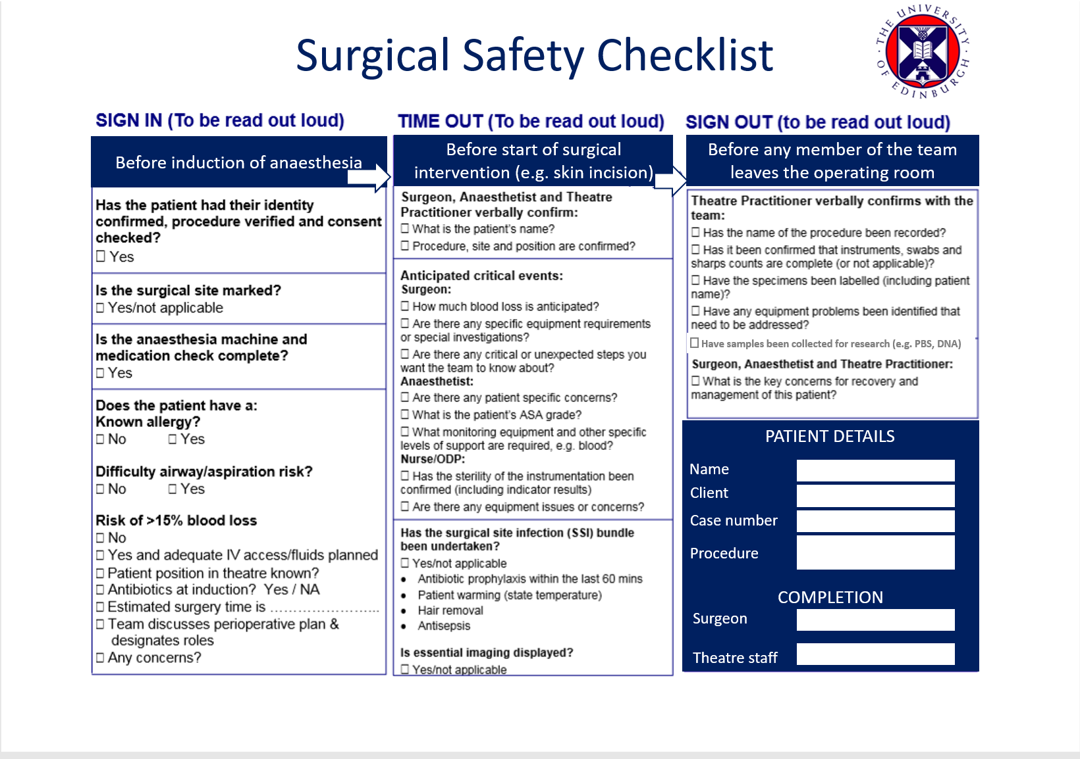

|  |  |  |
| --- | --- | --- |
| **SIGN OUT (to be read out loud)** | | |
| **Before any member of the team leaves the operating room** | | |
| **Theatre Nurse/Assistant verbally confirms with the team:**  Has the name of the procedure been recorded?  Has it been confirmed that instruments, swabs and sharps counts are complete (or not applicable)?  Have the specimens been labelled (including patient name)?  Have samples been collected for research (e.g. PBS, DNA)  Have any equipment problems been identified that need to be addressed?  **Surgeon, Anaesthetist and Theatre Nurse/Assistant:**  What are the key concerns for recovery and management of this patient? | | |
| **Patient Details** | | |
| **Name:** |  | |
| **Client:** |  | |
| **Case number:** |  | |
| **Procedure:** |  | |
| **Theatre Staff (Initials)** | | |
| **Surgeon(s):** | |  |
| **Anaesthetist:** | |  |
| **Theatre Nurse/Assistant:** | |  |
| **Theatre number:** | | |
| One Two Three Four | | |